.

[[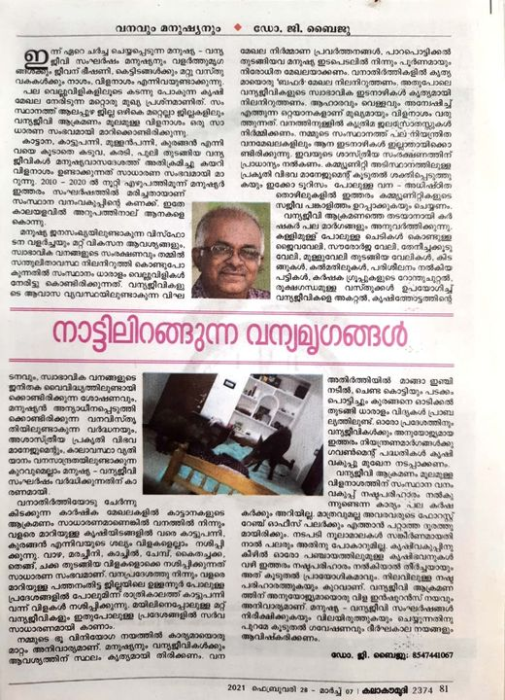](https://www.facebook.com/photo.php?fbid=3975073792514766&set=a.665462470142598&type=3&eid=ARC6hy9XwsEwOO7IV3cOseQ0EAtbSgd-nenC3QD8vjKgK7PDS_jgudkeXVF0PW8ayWx2qXeQP4rrePQD)](https://www.facebook.com/photo.php?fbid=3975073792514766&set=a.665462470142598&type=3&eid=ARC6hy9XwsEwOO7IV3cOseQ0EAtbSgd-nenC3QD8vjKgK7PDS_jgudkeXVF0PW8ayWx2qXeQP4rrePQD)

Top of Form